Monday of Easter at the Community
18/03/2012
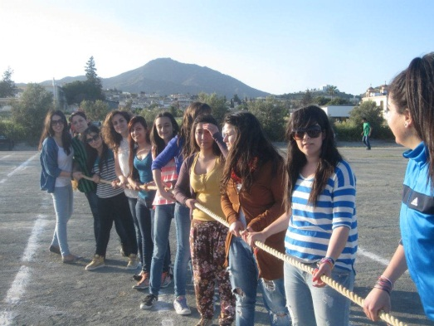

Traditional Games

- Rope Pulling-

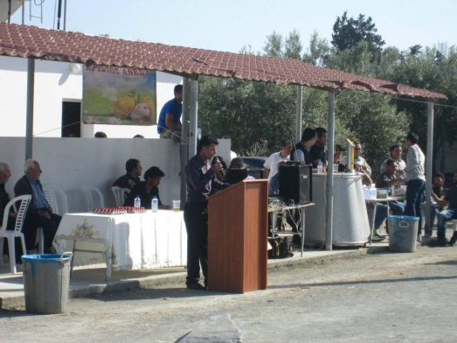

A speech by the President of the Community
Mr. Stavros Nicolaou

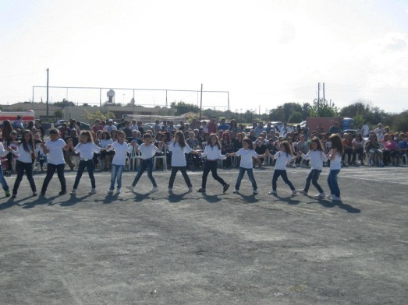

Traditional Dances
Performed by the Cultural
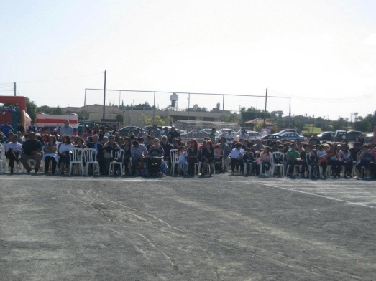
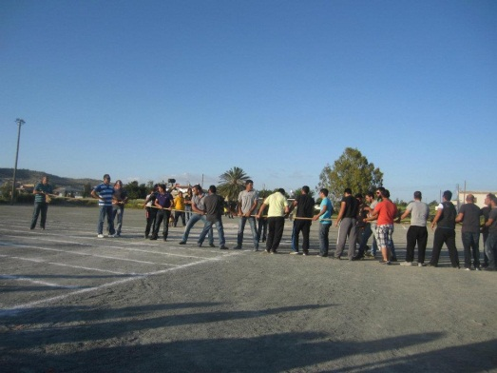
Club of Agglisides

Traditional Games

- Rope Pulling -

The villagers honoured
the event with their presence

